Trackly Technical Documentation
  - Architecture, Development, Features, and Operations
Fahmy Akhmad Firdaus
2026
Table of Contents

Document Information
Field | Value
Title | Trackly Technical Documentation
Subtitle | Architecture, Development, Features, and Operations
Author | Fahmy Akhmad Firdaus
Version | 1.0
Year | 2026
Language | English
Primary format | A4 portrait
Source | Curated from the Trackly repository and canonical Markdown documentation
This book describes the implementation present in the Trackly repository in 2026. It does not reconstruct undocumented project history, promise uncommitted features, or replace the canonical engineering documents under docs/.

Preface
Trackly is a personal productivity platform built around habits, goals, reminders, and derived analytics. Its implementation pairs a server-rendered Next.js application with a versioned Fastify API and PostgreSQL. The system is designed around authenticated ownership, logical calendar dates, explicit validation, and derived rather than persisted metrics.
This publication explains how those choices work together. Product chapters show the user-facing behavior; design chapters describe the boundaries behind it; engineering and operations chapters explain how to run, validate, and deploy it safely.
Tasks and the standalone Insights route are intentionally identified as unimplemented placeholders. Their navigation presence is not evidence of a completed product module.

How to Read This Document
- Read Parts I and II for architectural orientation.
- Use Part III to understand product workflows and business rules.
- Use Part IV while developing or reviewing changes.
- Use Part V before operating Trackly outside local development.
- Use Part VI for contracts, schema lookup, troubleshooting, and terminology.
The API and database chapters are compact publication references. The canonical API reference and database schema remain the exhaustive sources.
Note
Markdown is the source of truth. Mermaid figures in this manuscript are rendering inputs and must be converted to SVG before the final PDF or DOCX is produced.

Part I — Product and Architecture

1 Project Overview
Trackly combines habit tracking, task-oriented daily context, goal tracking, reminders, preferences, notifications, and analytics in one authenticated application. The implemented center of gravity is habit consistency: schedules produce logical occurrences; check-ins record absolute progress; goals and analytics derive meaning from those source records.

1.1 Product Goals
- Give users a calm daily view of scheduled work.
- Make recurring progress explicit without retaining meaningless zero rows.
- Keep data isolated by authenticated ownership.
- Respect user-local calendar boundaries across Today, schedules, streaks, reminders, and analytics.
- Provide extension points without placing business logic in transport or UI infrastructure.

1.2 Implemented Scope
Authentication, Today, categories, habits, goals, analytics, preferences, reminders, durable notification delivery, and browser Web Push are implemented. Tasks have a database/query foundation and placeholder page rather than a completed workflow. Standalone Insights is also a placeholder; analytics insights are implemented inside the Analytics dashboard.

1.3 Current Status
The repository includes production build targets, database migrations, structured logs, health/readiness checks, security controls, and extensive unit/integration coverage. It does not include production orchestration, TLS termination, automated backups, external monitoring, or deployment automation.

2 System Architecture
Trackly separates browser concerns, server rendering, API transport, domain services, repositories, and persistent data. Authentication is delegated to Better Auth. Reminder processing runs as a separate backend runtime, while Web Push remains behind a provider-neutral dispatcher.
Figure 2.1 — Trackly System Context
The frontend does not query PostgreSQL. The API does not place SQL in routes or controllers. User-specific reads avoid shared static caches, and ownership filters are applied in repositories.

3 Technology Stack
Area | Technology | Role
Frontend | Next.js 16, React 19, TypeScript | App Router, server rendering, focused client interaction
Styling | Tailwind CSS 4, shadcn/ui conventions, Lucide | Responsive design system and icons
Forms | React Hook Form, Zod | Typed forms and validation
HTTP | Axios plus server request utility | Central authenticated frontend API access
Charts | Recharts | Accessible analytics trends
Backend | Fastify 5, TypeScript | Plugin-oriented HTTP API
Validation | Zod | Params, query, body, environment, and public configuration
Database | PostgreSQL 17 | Relational ownership and logical-date storage
ORM | Drizzle ORM | Typed schema, queries, relations, and migrations
Authentication | Better Auth | Users, accounts, sessions, verification, cookies
Testing | Vitest, Testing Library, Fastify injection, Playwright tooling | Unit, integration, UI, and publication capture
Runtime | Docker, Docker Compose, pnpm workspaces | Repeatable development and production build stages
The stack favors explicit TypeScript contracts and libraries that work in both local development and containerized deployment.

4 Repository Structure
Trackely/
├── backend/ Fastify API, scheduler, database, and tests
├── frontend/ Next.js application and UI tests
├── docs/ Canonical and publication documentation
│ ├── 00-overview/
│ ├── 01-design/
│ ├── 02-features/
│ ├── 03-development/
│ ├── 04-deployment/
│ ├── 05-reference/
│ ├── assets/
│ └── publication/
├── scripts/docs-screenshots/
├── docker-compose.yml
├── package.json
├── pnpm-workspace.yaml
└── AGENTS.md
The workspace contains two application packages rather than an apps/ or shared packages/ monorepo hierarchy. Database schema and migrations live inside the backend. Repository-wide commands orchestrate both packages.

Part II — Application Design

5 Frontend Architecture
The frontend uses the Next.js App Router and defaults to React Server Components. Protected route groups obtain the Better Auth session server-side, fetch user-specific data with no-store, and render stable initial UI. Client Components are limited to forms, mutations, theme control, check-ins, reminder management, and browser Web Push.

5.1 Routing and Layout
Public authentication pages use a dedicated layout. Authenticated routes share an application shell with desktop sidebar, top bar, responsive content area, and fixed mobile navigation. Route-level loading, error, and not-found files provide localized recovery.

5.2 Data and State
- Shareable list and analytics selections live in URL parameters.
- React Hook Form owns temporary form state.
- Focused component state manages pending and feedback behavior.
- No global client data cache or React Query layer is present.
- Server requests use a shared parser, timeout, cookie forwarding, and safe error mapping.
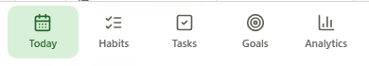
Figure 5.1 — Mobile Primary Navigation

6 Backend Architecture
Fastify is assembled in app.ts without opening a port. server.ts owns startup and graceful shutdown. Plugins register authentication, database access, request context, security, CORS, rate limiting, Swagger, and centralized errors.
Figure 6.1 — Authenticated Request Lifecycle
Controllers translate HTTP input and output. Services enforce business, schedule, and timezone rules. Repositories own database access. This lightweight CQRS separation is most visible in the Habit read and command paths.

7 Authentication and Authorization
Better Auth owns password hashing, accounts, sessions, verification records, cookies, and /api/auth/*. Trackly resolves sessions through Better Auth’s server API rather than decoding cookies. Protected pages redirect to login; protected API routes return the standard 401 error envelope.
Figure 7.3 — Email and Password Authentication Sequence
Authorization is ownership-based. The authenticated user ID is passed into services and repositories; public request bodies never choose an owner. Deleted, missing, and foreign habit records intentionally share not-found behavior.
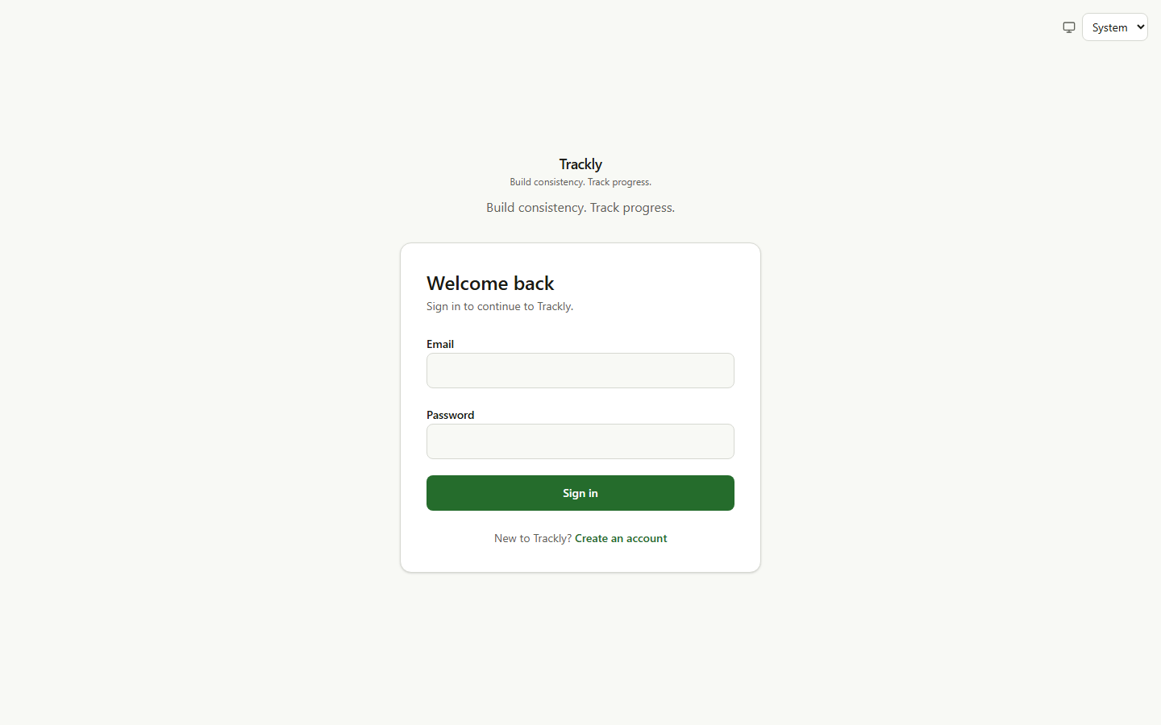
Figure 7.1 — Trackly Sign-In Experience
Registration uses the same authentication-owned contract and creates a default preference row for the new user.
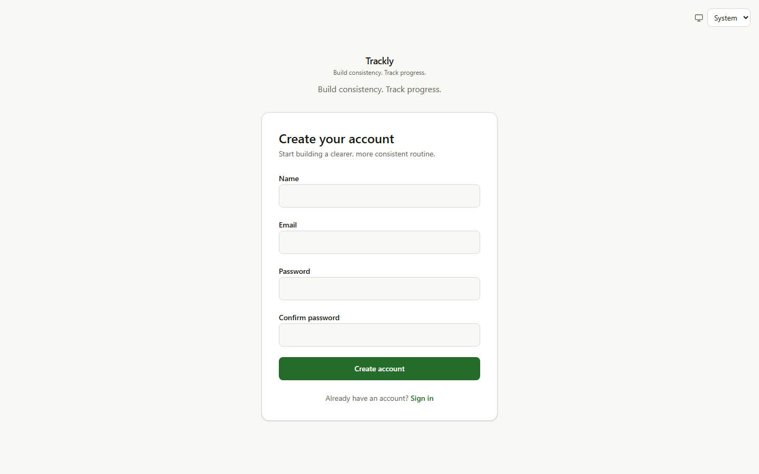
Figure 7.2 — Account Registration

8 Database Design
PostgreSQL stores authentication records, user preferences, categories, habits, schedules, check-ins, tasks, goals, goal steps, reminders, notification deliveries, and browser push subscriptions. Drizzle defines tables, relations, constraints, indexes, and migration snapshots.
Figure 8.1 — Trackly Entity Relationships
Tables and columns use snake_case. UUIDs identify Trackly domain entities; Better Auth retains its own text identifiers. Logical days use PostgreSQL date, while instants use timezone-aware timestamps. Soft-deletable resources carry nullable deleted_at.
Migrations are reviewed and forward-only. db:push is limited to local development. Transactions protect dependent mutation steps, occurrence claims, and other atomic workflows.

9 API Design
Trackly application endpoints live under /api/v1. Better Auth owns /api/auth/*; /health, /ready, and conditionally exposed /docs remain unversioned infrastructure routes.
Success responses use:
{
"success": true,
"data": {},
"meta": {}
}
Errors use stable codes and JSON-safe optional details:
{
"success": false,
"error": {
"code": "VALIDATION_ERROR",
"message": "Request validation failed.",
"details": []
}
}
Zod validates params, query strings, bodies, and configuration. The centralized handler maps Zod, Fastify validation, malformed JSON, application errors, missing routes, and unexpected failures without exposing stack traces or raw database errors.

Part III — Features

10 Today Dashboard
Today is the user’s local-calendar command center. It combines scheduled habits, task group projections, active goals, and a daily summary. A URL date parameter supports explicit date navigation without losing refresh or browser-history state.
Habit progress uses the source check-in count for the selected date. Tasks are represented only through their existing query foundation; no mutation UI is present. Goal cards show step summaries, while detailed goal progress is derived elsewhere from habit check-ins.
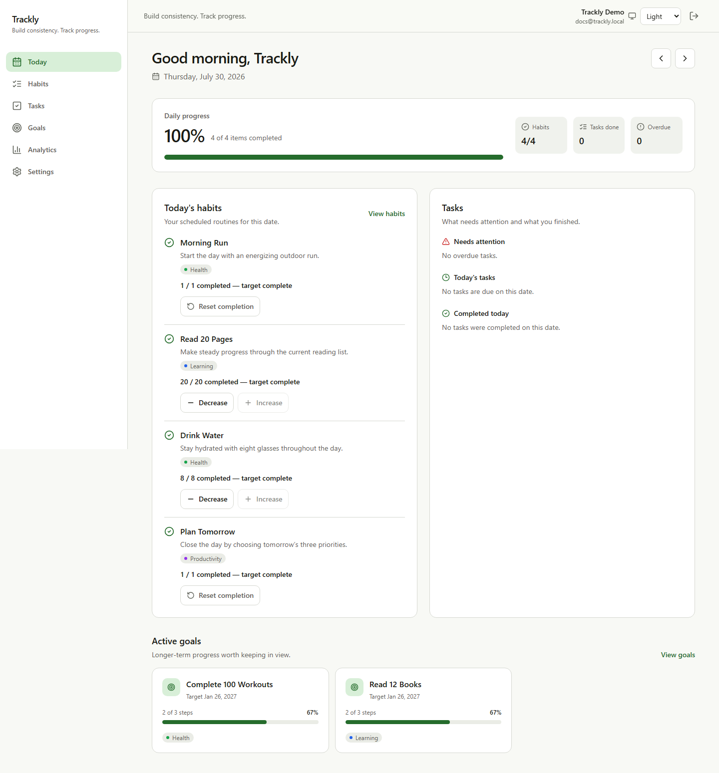
Figure 10.1 — Today Dashboard with Daily Progress
On narrow screens, cards stack and mobile navigation remains fixed without horizontal overflow.
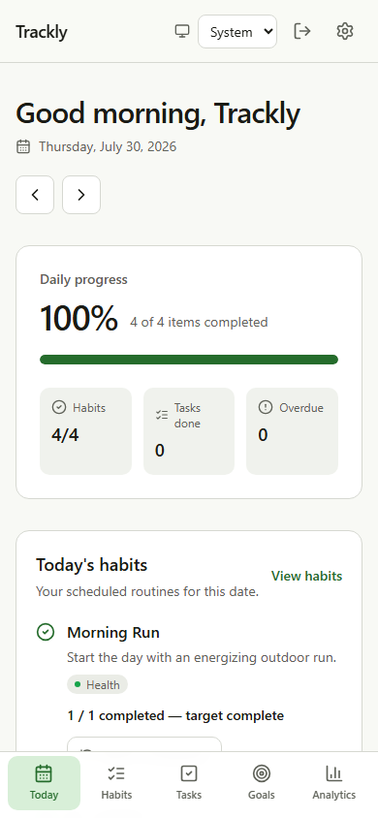
Figure 10.2 — Today Dashboard on Mobile

11 Habits
Habits support collection/detail reads, create, partial update, archive, restore, soft deletion, check-in, streak, category association, schedule, and reminder management. Collection controls are browser-native GET forms so view, date, search, sort, order, and page survive refresh and sharing.
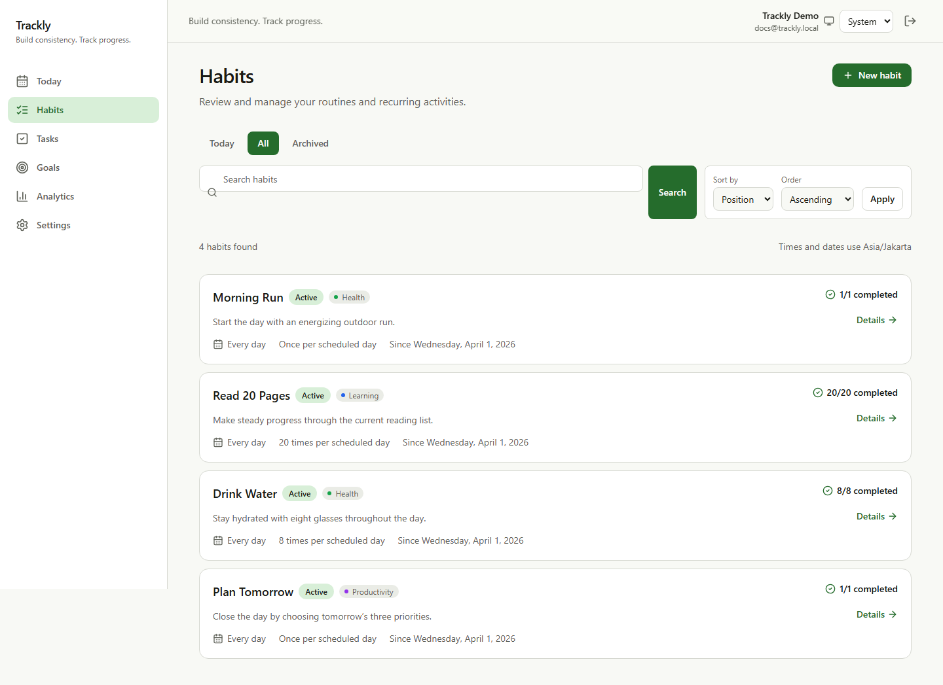
Figure 11.1 — Habit Collection and URL-Based Controls
Create and edit forms use Zod-backed React Hook Form validation. Daily, weekly, and custom schedules share backend schedule utilities.
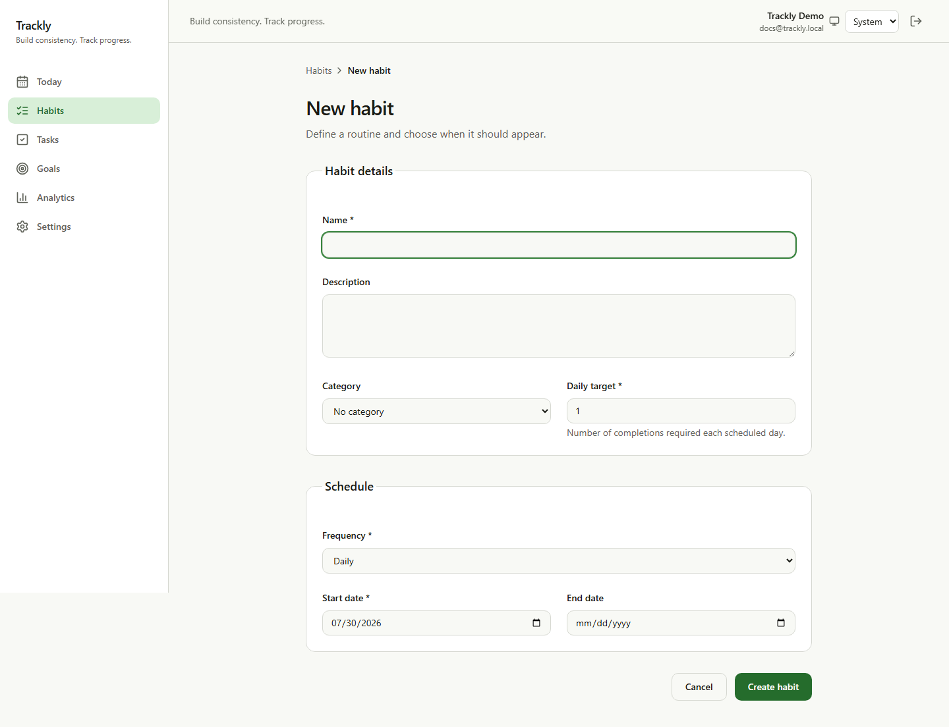
Figure 11.2 — Habit Creation Form
Check-ins send the final absolute completedCount, not an increment command. Target-one habits toggle between one and zero; multi-target habits increment or decrement within bounds. Zero removes the stored row.
Figure 11.5 — Absolute Habit Check-In Flow
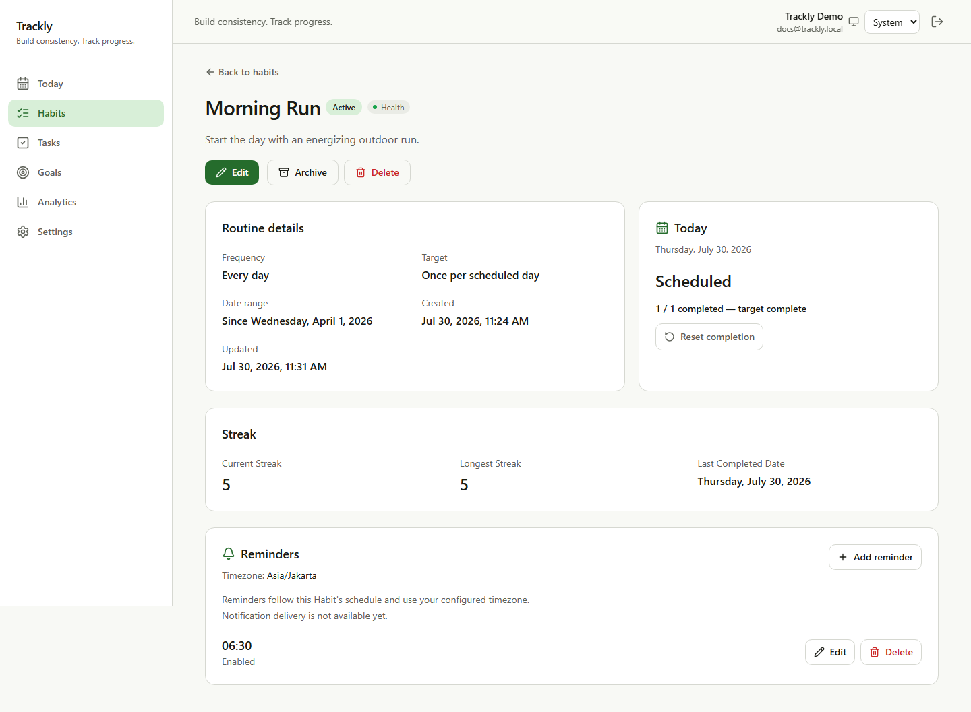
Figure 11.3 — Habit Detail, Check-In, and Streak
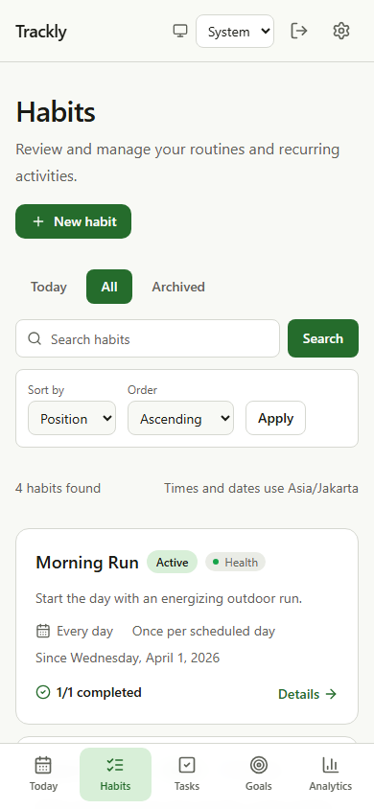
Figure 11.4 — Habit Collection on Mobile

12 Goals
Goals define finite accumulation targets linked to owned habits. Progress is calculated from habit check-ins inside the goal date range and capped only where the consuming metric requires it. The dashboard groups active goals by progress, deadline, target achievement, and over-target state.
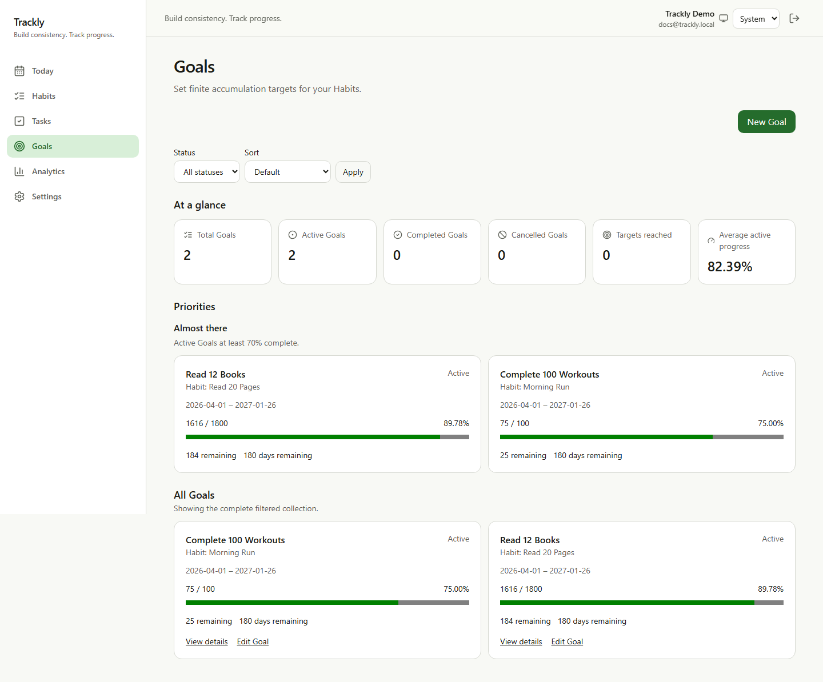
Figure 12.1 — Goal Dashboard and Derived Progress
Create, update, and delete operations verify that the linked habit and optional category belong to the authenticated user. Goal steps provide a separate checklist projection used by Today.

13 Categories and Preferences
Categories provide optional user-owned labels for habits and goals. The current public API lists active categories; it does not expose category-management commands.
Preferences store timezone, week start, date format, time format, and theme. Timezone is a domain input, while other preferences primarily affect presentation. Missing preference rows resolve documented defaults, and invalid legacy timezones safely fall back to UTC in dependent services.
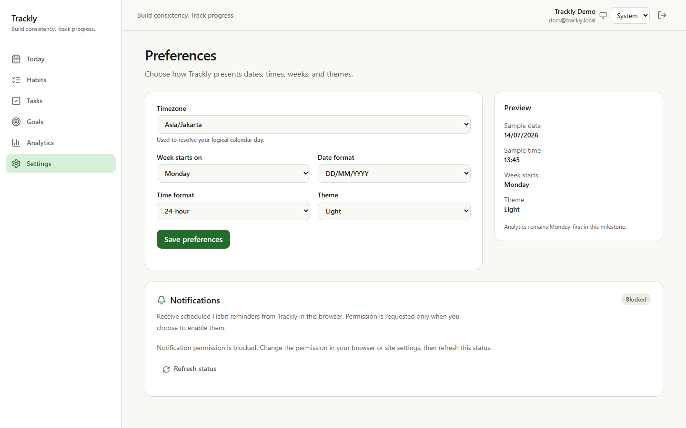
Figure 13.1 — Preferences and Device Notification Settings

14 Analytics
Analytics is read-only and calculated on demand. It reuses a bounded repository snapshot to serve summary, history, insights, heatmap, and rankings without six overlapping database reads.
Completion rate answers whether scheduled occurrences reached their target. Progress rate answers how much capped target volume was completed. These values intentionally differ for partial multi-target habits.
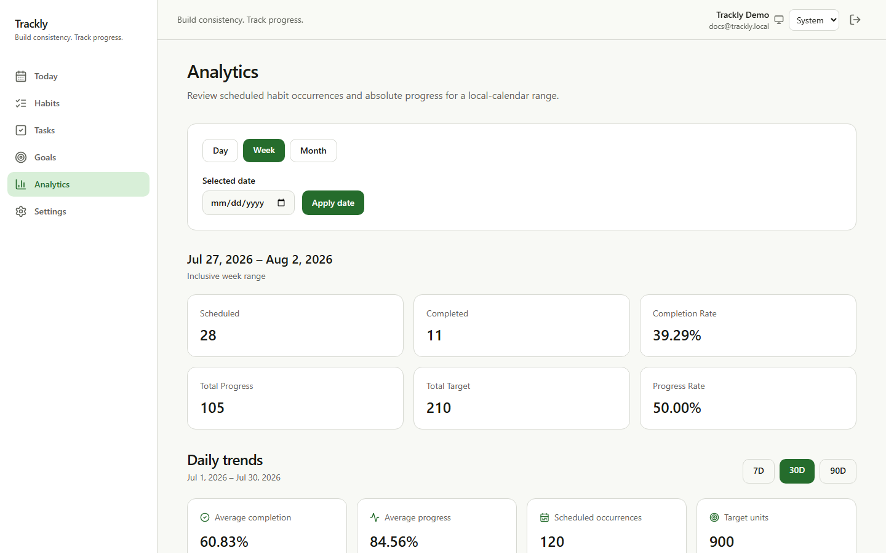
Figure 14.1 — Analytics Summary and Daily Trends
History includes every local date in its range, including zero-activity dates. Insights exclude inactive days where required, use deterministic tie-breaking, and compare equal recent/previous windows. The heatmap preserves the calendar shape while rankings remain user-scoped.
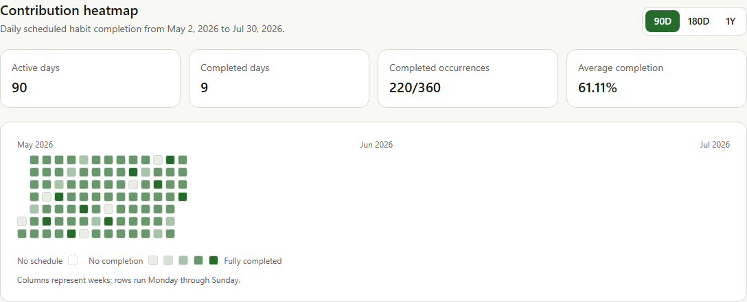
Figure 14.2 — Contribution Heatmap

15 Reminders and Web Push
Reminders attach local times to habits. Eligibility considers authenticated ownership, habit lifecycle, schedule, completion, date, timezone, and the configured reminder time. A separate scheduler evaluates due occurrences.
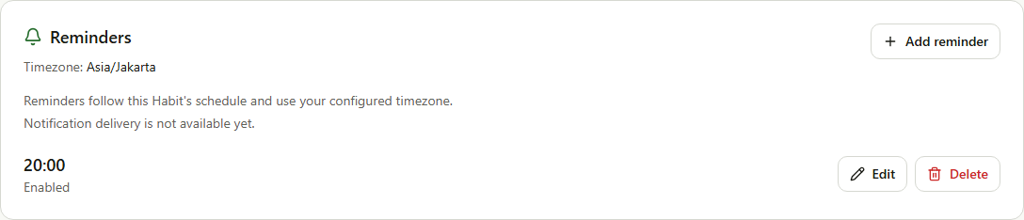
Figure 15.1 — Reminder Management on Habit Detail
Figure 15.2 — Reminder Scheduling and Notification Delivery
Browser subscriptions are device-specific. Permission is requested only after an explicit action. The service worker displays minimal payloads and constructs only known internal navigation targets. HTTP 404/410 invalidates expired subscriptions; transient failures do not trigger automatic retry.

Part IV — Engineering

16 Local Development
Trackly uses pnpm workspaces. Node 24 matches the Docker build images, and pnpm 10.13.1 is declared by the root package.
corepack enable
pnpm install
Copy-Item .env.example .env
docker compose up --build
The frontend defaults to port 3000, backend to 4000, and PostgreSQL to 5432. Host processes use localhost; containers use Compose service names.

17 Environment Configuration
Backend configuration is parsed and validated before startup. Production requires HTTPS authentication/trusted origins, a non-placeholder Better Auth secret, disabled diagnostics, and complete VAPID configuration when Web Push is used.
Frontend public configuration is limited to browser-safe URLs and the VAPID public key. NEXT_PUBLIC_* variables are visible to clients and must never contain database credentials, private VAPID material, or authentication secrets.
Security
Populate environment values through the deployment secret mechanism. Never commit a populated .env file.

18 Testing
Vitest covers backend services/routes, frontend components/services, and PostgreSQL integration behavior. Fastify injection avoids opening network ports for HTTP contract tests. External Web Push and browser APIs are mocked.
pnpm format:check
pnpm lint
pnpm typecheck
pnpm test:backend
pnpm test:frontend
pnpm test:database
pnpm build
docker compose config --quiet
git diff --check
The database suite remains separate from pnpm validate because it requires PostgreSQL. Publication screenshots use a dedicated Playwright workflow and reserved documentation account.

19 Debugging
Begin with the smallest boundary:
- Capture the failing command, route, response status, and request ID.
- Compare /health with /ready.
- Inspect the relevant frontend, backend, PostgreSQL, or scheduler logs.
- Verify host-versus-container URLs.
- Reproduce with a focused test.
Public errors remain generic. Server logs may contain stack traces for unexpected failures, but redaction prevents credential and token fields from being logged.

20 Docker and Database Migrations
Development Compose starts PostgreSQL, waits for its health check, starts the backend, waits for backend readiness, and then starts the frontend.
pnpm db:generate
pnpm db:migrate
pnpm db:seed
pnpm test:database
Schema changes require reviewed migrations. The production backend image is not a self-contained migration image because it does not copy the SQL migration directory; a deployment must supply a release workspace or purpose-built migration job.

Part V — Deployment and Operations

21 Production Deployment
The repository supplies multi-stage frontend and backend production Docker targets. Both run as non-root users. The frontend uses Next.js standalone output; the backend runs compiled JavaScript. PostgreSQL and the scheduler are separate runtime responsibilities.
Figure 21.1 — Supported Deployment Topology and External Boundaries
Figure 21.2 — Container Startup Dependencies

22 Reverse Proxy and Networking
No reverse proxy configuration is checked in. Production must supply TLS termination, preserve the host/protocol needed by Better Auth, route frontend and backend paths correctly, forward validated request IDs, and align CORS with trusted origins.
Static Next.js assets may use immutable caching where filenames are content addressed. Authenticated HTML and API responses must not enter shared caches. TRUST_PROXY should be enabled only behind a known proxy topology.

23 Monitoring and Logging
Pino emits readable development logs and machine-readable production JSON. Request completion records include timestamp, level, request ID, method, path, status, duration, and authenticated user ID when available. Audit events record actor, action, resource, outcome, and request ID.
Trackly provides /health for liveness and /ready for PostgreSQL readiness. It does not ship an external log platform, metrics, tracing, dashboards, or alerts. Operators must retain logs and alert on readiness failures, error rates, scheduler failures, and notification delivery outcomes.

24 Backup and Recovery
The development postgres_data volume provides persistence, not backup. The repository does not implement scheduled backups, retention, encryption, point-in-time recovery, or restore automation.
Production requires an external PostgreSQL backup plan with tested restore procedures. Recovery must restore schema and data coherently, apply only reviewed forward migrations, and verify authentication, ownership, check-ins, goals, reminders, and notification records.

25 Security and Operational Readiness
Implemented controls include Helmet security headers and CSP, CORS allowlists, HttpOnly Better Auth cookies, structured redaction, Zod validation, environment hardening, request IDs, process-local rate limiting, authenticated ownership, safe internal notification routing, and non-root production images.
Operational Limitations
Trackly does not include TLS/reverse proxy configuration, production orchestration, distributed rate limits, scheduler leadership, automated backups, external monitoring, CI/CD, or rollback automation.
A production review must define secret rotation, proxy trust, cookie behavior, database recovery objectives, migration ownership, one scheduler leader, central log retention, alerts, and capacity budgets.

Part VI — Reference

26 API Reference
The implemented API groups are:
Group | Namespace | Authentication
Health/readiness | /health, /ready | Public
Swagger | /docs when enabled | Public when exposed
Better Auth | /api/auth/* | Framework-specific
Current user | /api/v1/auth/me | Required
Today | /api/v1/today | Required
Categories | /api/v1/categories | Required
Habits and streak/check-in | /api/v1/habits/* | Required
Goals | /api/v1/goals/* | Required
Preferences | /api/v1/preferences | Required
Reminders | /api/v1/habits/:habitId/reminders/* | Required
Push subscriptions | /api/v1/push-subscriptions | Required
Analytics | /api/v1/analytics/* | Required
List endpoints document their own pagination, filtering, and deterministic sorting. Rate-limited routes return the standard 429 envelope. Swagger is generated from registered Fastify schemas and may be disabled in production.
For every request field, response model, error, and service mapping, use the canonical API reference.

27 Database Reference
The schema contains fourteen implemented tables:
user, session, account, verification, categories, habits, habit_schedules, habit_check_ins, tasks, goals, goal_steps, user_preferences, reminders, notification_deliveries, and push_subscriptions.
Better Auth owns the first four authentication tables. Domain tables use database constraints, ownership indexes, and explicit cascade/set-null behavior. The task table exists, but the product workflow remains incomplete.
The canonical database reference lists every column, type, default, foreign key, index, unique constraint, check constraint, enumeration, relation, and lifecycle rule.

28 Troubleshooting
Symptom | First checks
Stack does not start | docker compose config, service status, port collisions, logs
Healthy but not ready | Database URL, PostgreSQL health, network, credentials, migrations
Authentication loop | Auth URLs, trusted origins, CORS, cookies, HTTPS
Frontend cannot call API | Browser URL versus internal server URL
HTTP 429 | Configured window, duplicate submissions, trusted proxy
Scheduler does not deliver | Separate process, database, eligibility, provider, singleton ownership
Web Push unavailable | HTTPS/localhost, public/private VAPID config, browser permission
Build/test failure | Run formatting, lint, type, package tests, and build independently
Do not expose secrets in incident reports. Preserve timestamps, deployment version, route, and sanitized request IDs. Full procedures are in Troubleshooting.

29 Frequently Asked Questions

29.1 Is analytics persisted?
No. Analytics, streaks, percentages, and goal progress are derived.

29.2 Does the backend start the scheduler?
No. The scheduler is a separate runtime.

29.3 Can a client choose a user ID?
No. Ownership always comes from the authenticated session.

29.4 Can db:push deploy production schema?
No. Production uses reviewed migrations.

29.5 Is a Compose volume a backup?
No. It is local persistence.

29.6 Does Trackly use Firebase?
No. Browser notifications use standard Web Push with VAPID.
See the complete FAQ.

30 Glossary
Term | Meaning
Logical date | A YYYY-MM-DD calendar date interpreted in the user’s timezone
Occurrence | A derived scheduled habit instance for one logical date
Check-in | Absolute progress stored for one habit/date
Active day | A date with at least one scheduled occurrence
Completion rate | Completed occurrences divided by scheduled occurrences
Progress rate | Capped completed volume divided by target volume
Soft delete | Retention through nullable deleted_at
Request ID | Correlation identifier returned in x-request-id and logs
Provider | Explicit notification delivery adapter such as noop or web_push
Readiness | Ability to query PostgreSQL and serve database-dependent traffic
See the complete Glossary.

31 Decision Log
Current repository-backed decisions include:
- TypeScript across application code.
- Versioned Trackly application endpoints.
- Controller, service, and repository separation.
- PostgreSQL and Drizzle with reviewed migrations.
- Better Auth ownership of authentication data.
- User-timezone logical dates.
- Derived metrics rather than persisted aggregates.
- Server-rendered reads with focused client boundaries.
- Provider-neutral notification delivery.
- Structured logs and audit events without a persisted audit table.
- Development Compose plus production image targets.
The Decision Log records context, consequences, and evidence without inventing dates or authors.

Appendices

Appendix A — Useful Commands
pnpm dev
pnpm validate
pnpm test:database
pnpm build
pnpm db:generate
pnpm db:migrate
pnpm db:seed
pnpm audit:security
pnpm docs:screenshots
docker compose up --build
docker compose config --quiet
git diff --check

Appendix B — Known Limitations
- Tasks and standalone Insights remain placeholder-only.
- Category management has no public mutation workflow.
- Analytics uses fixed periods rather than arbitrary date ranges.
- Web Push is the only real notification provider.
- Notification delivery has no automatic retry queue or history UI.
- Scheduler leadership is not distributed.
- Rate limiting is process-local.
- Swagger exposure, TLS, backups, monitoring, and production orchestration are deployment responsibilities.
- The production backend image is not a migration runner.
- PDF/DOCX and Mermaid-SVG generation are not yet automated.

Appendix C — Future Improvements
Repository-backed engineering needs include production deployment definition, migration packaging, backup/restore drills, external log retention and alerts, frontend health checks, scheduler ownership, distributed rate limiting for multi-replica deployment, performance budgets, and documentation publication automation.
No unimplemented product capability is presented as committed roadmap.

Appendix D — Documentation Maintenance
Canonical Markdown remains authoritative. When implementation changes:
- Update the relevant canonical design, feature, development, deployment, API, or database document.
- Update the publication chapter only when the change affects its narrative.
- Regenerate deterministic screenshots when visible UI changes.
- Update screenshot and figure manifests.
- Validate relative paths, internal anchors, duplicate headings, fences, Mermaid rendering, CSS, and formatting.
- Generate PDF and DOCX from reviewed Markdown.
- Visually inspect every page before publication.
The publication README and publication plan define the next rendering stage.

